OOP Assignment #3
Name: Yash Raj
Roll number: 24k-0737

Registeration process:

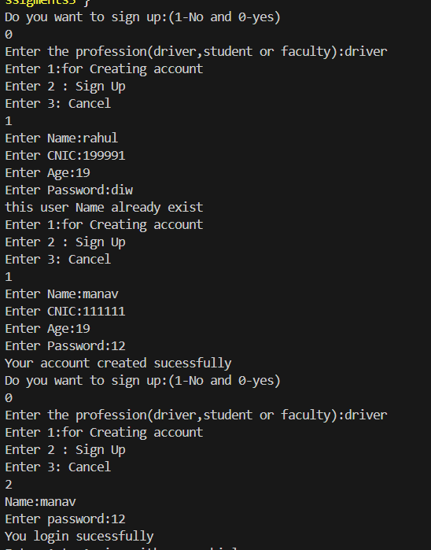

These information of registeration is taken from files of DriverDetails.txt and for creating new account, I append user data in this file.
=> This program also restricts users from use the same user name, and there are multiple features like that which I include in my program
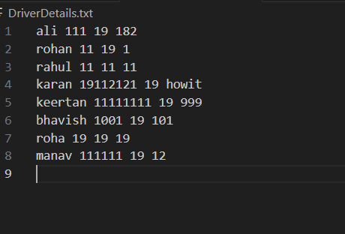

And there are 3 txt files for storing data of the user(students.txt, Faculty.txt,DriverDetails.txt)
Driver Part
Driver has option to choose transporter and vehicle , but when driver chooses one vehicle from any transporter then No other driver can choose the same vehicle .

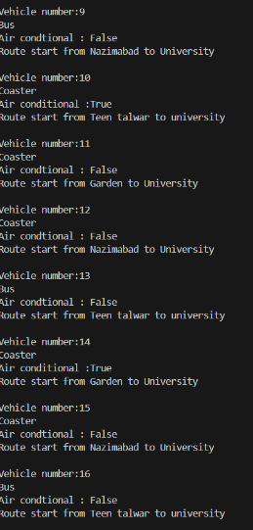
=> Maybe you noticed from these images that some vehicles are missing, like 20,21,22, etc.

=> It is because these vehicles are already assigned to another driver, so now the current driver has no option to choose the assigned
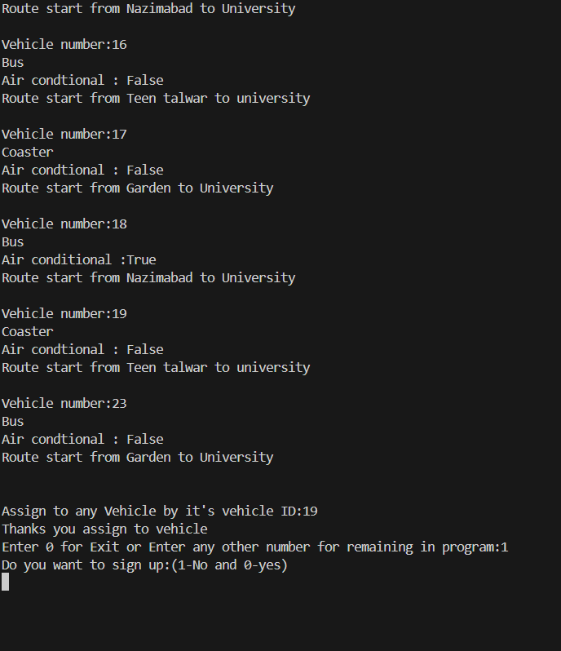

=>Now, all these things are in 3 files (AssigningVehicle.txt, NadeemRoute.txt, and ZulfiqarRoute.txt ) that play an important role
=> NadeemRoutes.txt and ZulfiqarRoute.txt are files that contain all information about all vehicles that the transporter has
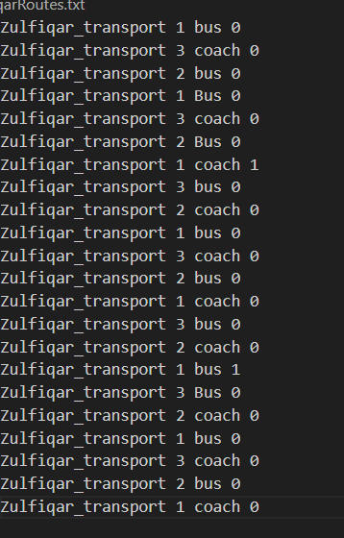

And last AssigningVehicle.txt stores vehicle information that was assigned by any driver.

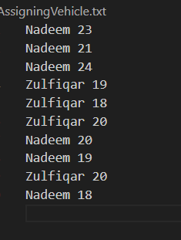

Student and Faculty Role:
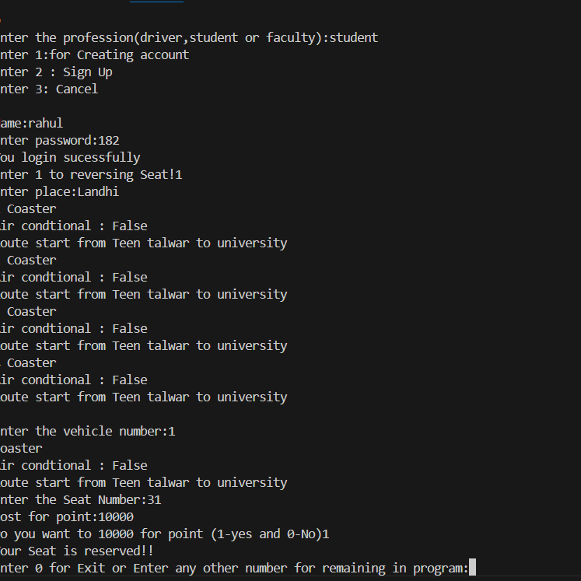

As you see in output after sign up , we get option for sit reserving if we click it then program asked about location then it give us all vehicle which include this location and it has also driver
After doing this we get payment option in which we have to pay cost that is 10000 for student and faculty but if It was Aircondtional then student have to pay 13500 and faculty 12000
Also In coaster 1-8 seats are reserved for faculty and remaining for student and in bus starting 12 for faculty and remaining for student

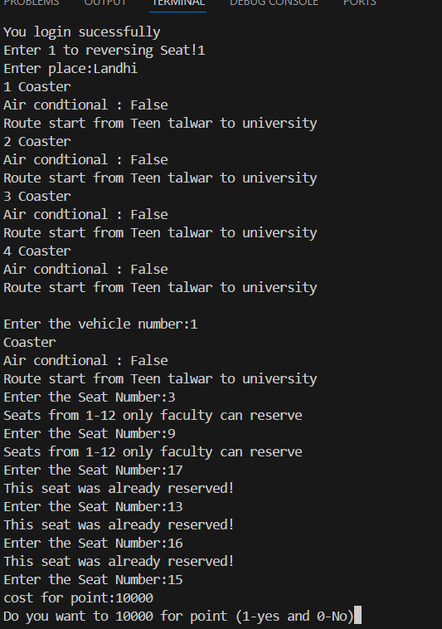

And all these information of booking are stored in Booking.txt

